26th -28th July 2K visited Helsinki for the first time, hosted by HSS.

On Friday morning the teams raised the taxi flag on the mainland to order their rides across the 50 metre stretch of water to the spectacular island HSS lives on.

In bright sunshine the wind had filled in by 11 and the teams were racing the other side of the island in the six Continental Elliots.

At the end of day one RTYC were leading DMTRA, benefiting from DJ kissing the finish boat with boom.

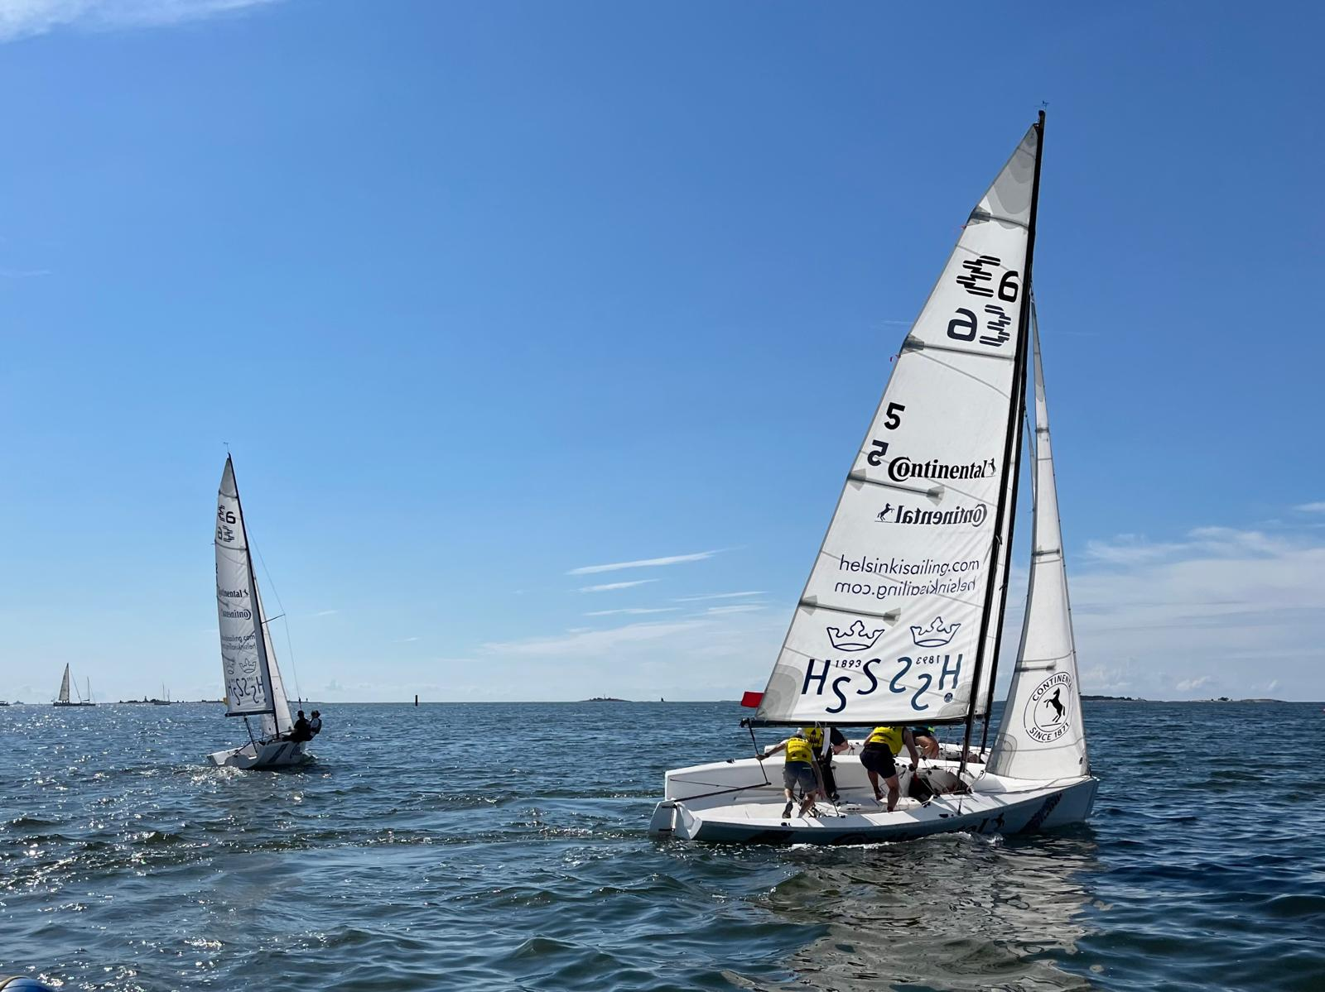

The new team from HSS had shown everyone they knew how to start, but a lack of experience was holding them back round the race course.

HSS hosted dinner on the island looking out over the sound and some team racing tips were offered to HSS. And they were listening. On a windier day 2 they went straight out and beat the Belgians and Serpentine who were down to 5 loses vs 2 for RTYC and DMTRA.

But in a crucial grudge match between Serpentine and RTYC the tables were turned.
That evening the teams traded on water competition for a battle for space on BBQ to prepare dinner before the more energetic head for a late night of Helsinki clubs and in the case of the Belgians some sauna.

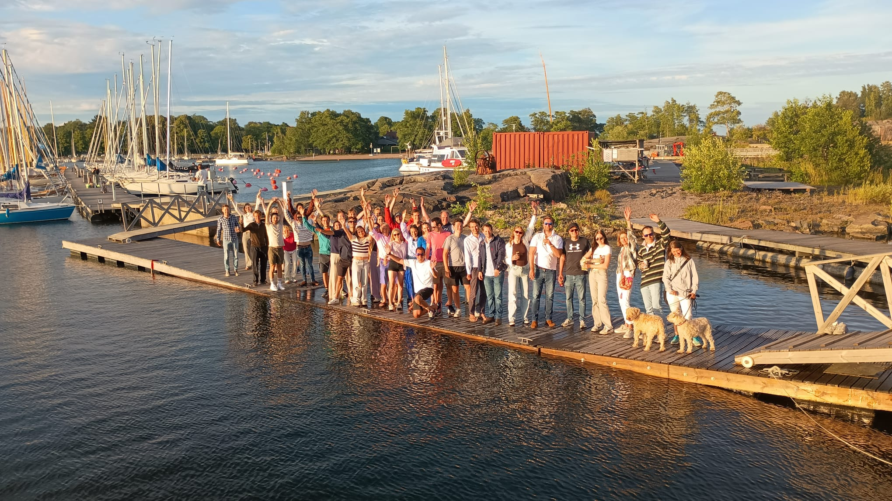

Sunday was lighter but crucially 10 more races were fitted in and Serpentine beat RTYC again the penultimate race to secure a place in the final on count back against the dutch.
In three tightly fought races the starts proved irrelevant with DMTRA clawing back a terrible start in race 1, followed by Serpentine doing the same in race two.
In the final race Serpentine again came off the line better and again DMTRA fought back, locking in the win 50m from the finish of the race.

All in all it was an amazing event. Despite their first time hosting a 2K the race committee pulled off 3 and half round robins. The HSS team showed a lot of potential beating some teams and threatening everyone.

Thanks to Amin for his amazing organisation and we hope to be back again next year.

Final Results
Position | Team
1 | DMTRA
2 | Serpentine
3 | Royal Thames
4 | Bayerischer YC
5 | Belgium
6 | HSS

