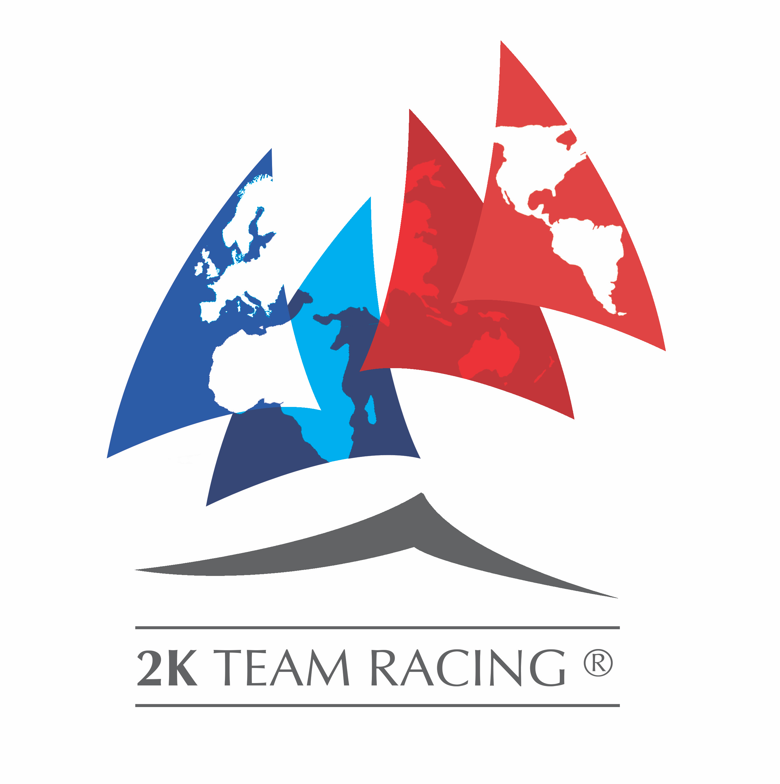

Check off list of Equipment needed for 2K event:

Keelboats

6 keelboats... ☐

Boats to be all equal, or equalized into 3 sets. ☐

Racing Boat Identifier flags 0.2m x 0.2m for shrouds and backstay

Supplied by 2K Association ☐

Competitor racing flags 30cm x 30 cm on floating wooden sticks ( 1 for each boat plus 2 spare)

8 x Yankee ☐
8 x White/Lima ☐
8 x Red ☐

Motor Boats

1 x Committee Boat ☐ Plus Radio ☐
2 x Umpire Ribs ☐ Plus Radio ☐
1 x Change Rib ☐ Plus Radio ☐
1 x Repair Rib ☐ Plus Radio ☐
1 x Mark boat ☐ Plus Radio ☐
1 x Island Boat(for crews not racing) ☐ Plus Radio ☐

Committee Boat:

3 persons ☐

Flags
1 x Large Orange Flag ☐
3 x Warning Flags: 1 Red, ☐ I Yellow, ☐ and 1 Blue ☐
3 x OCS Flags on sticks 1 Red ☐ 1 Yellow ☐ 1 Blue ☐
1 x Prep ☐
1 x AP ☐
1 x N ☐
1 x Y ☐

Horn or similar for sound signals. ☐
Radio to contact shore and umpires ☐

Paperwork needed.

Race schedule ☐
Sailing Instructions ☐
Local Sailing Instructions ☐

Umpire Flags 70cm x 70 cm on floating wooden poles (1m long)
Or supplied by 2K Association ☐

2 x Yellow ☐
2 x Red ☐
2 x Blue ☐
2 x Black and White ☐
2 x Green and White ☐

Marks

1 ODM ☐
3 Course Marks ☐

