2K Rules Explanation 6 Luffing to head to wind.

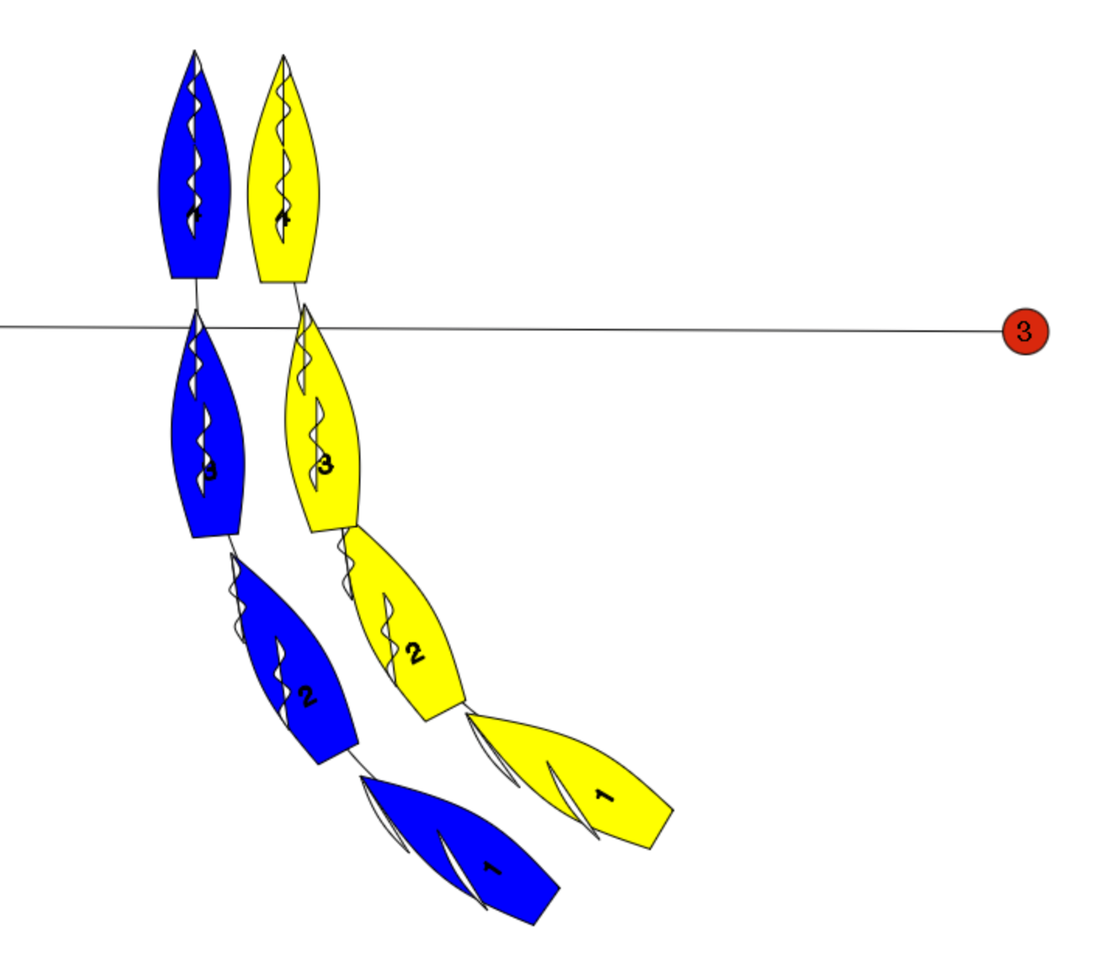

Blue is overlapped to leeward of Yellow.

Blue luffs Yellow head to wind at position 3.

Yellow protests and hails “You’re above close hauled you can’t make me tack”. What should the umpires do?

Display a Green and White Flag.

At all times Blue is leeward right of way unless she passes head to wind.

When Blue changes course to windward she must give Yellow room to keep clear…which she does.

At position 3 Blue stops changing course at which point Yellow has room to tack.

At position 4, if Yellow is not keeping clear then Yellow breaks rule 11.

In Short

- In 2K (and in other racing when rule 17 is not deleted) there is no rule that prevents a leeward boat from luffing to head to wind. As long as when changing course she gives the other boat room. If the windward boat has to tack to keep clear, then she must tack.

