2K Rules Explanation 5 Approaching and Leaving a mark- Interfering

Case 1
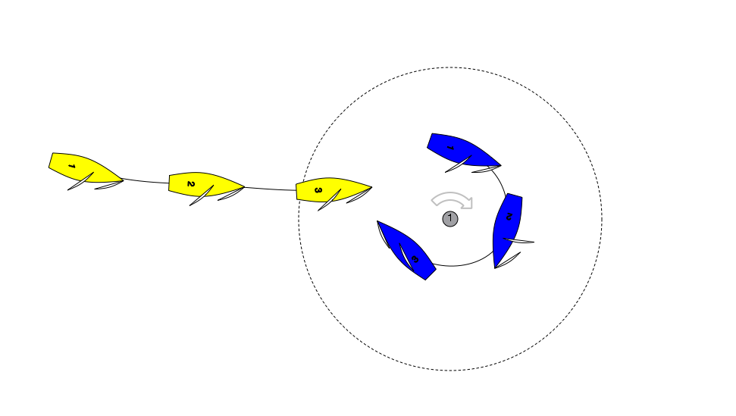

Question: Blue enters the zone of the Leeward mark clear ahead of Yellow. Blue rounds up to a proper course and immediately after position 3 Blue has to bear away sharply to avoid a collision. Blue protests. What should the call be.

Answer: Green and White Flag. As drawn Yellow is approaching the mark and Blue is leaving the mark. Therefore Rule 18 does not apply. Blue the right of way boat is restricted by Rule 16 and when changing course must give Yellow room to keep clear. By bearing away Blue has given Yellow Room to Keep Clear (see Call D3.)

Yellow in addition must keep clear.

Case 2

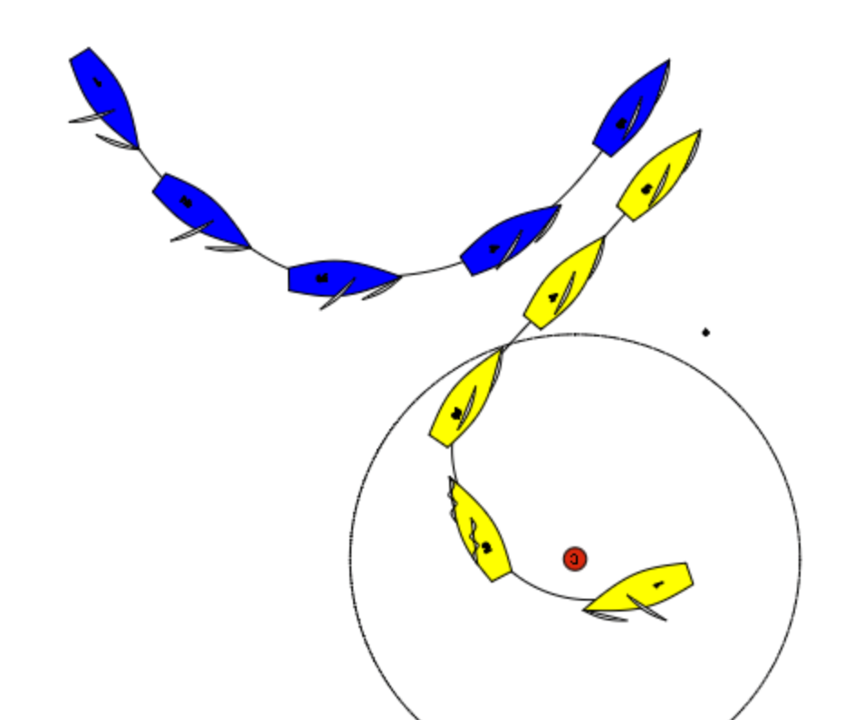
This is not uncommon, and something Blue needs to consider as she approaches the leeward mark. Yellow and Blue are on different legs and Yellow is clearly making life hard for Blue…but although she may be interfering with Blue, Yellow is sailing her proper course. If Yellow was sailing above or below her proper course she may be breaking rule 23.2. If Yellow is sailing a proper course no rule is broken.

