2K Rules Explanation 4: Windward Leg Dial Down

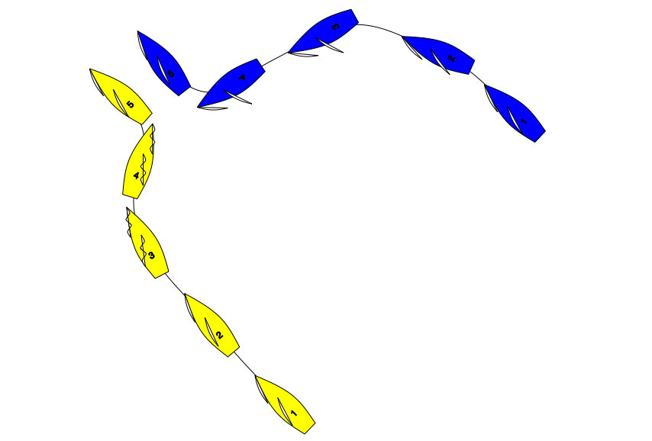

On a beat to windward Blue anticipates that Yellow will have to tack. At position 3 as Yellow starts to point up Blue bears away strongly on to a collision course. Before Yellow reaches head to wind Blue locks her tiller (stops changing course). At position 4 to avoid a collision both boats change course sharply. There is a protest, what should the call be?

Answer: Penalise Yellow.

In position 1,2 and 3 Blue is windward keep clear boat.
At position 4 Blue becomes right of way boat as a result of Yellow’s actions.
Rule 15 and 16 do not apply as Blue has not changed course and Blue acquires right of way in part because of Yellow’s actions.

Yellow breaks rule 10.

Note: if after Yellow passes head to wind Blue changes course, then Blue is subject to rule 16. In which case the answer is Green and White Flag.

