2K Rules Explanation 3 Interfering with a boat taking a Penalty

Case 1

Yellow and Blue are approaching a windward mark to be left to starboard. At position 2 Yellow luffs rapidly and there is contact. Yellow immediately hails “spinning”, raises an arm and starts to bear away to take a voluntary penalty.

Blue immediately bears away on to a course to prevent Yellow from gybing.

There is a protest.

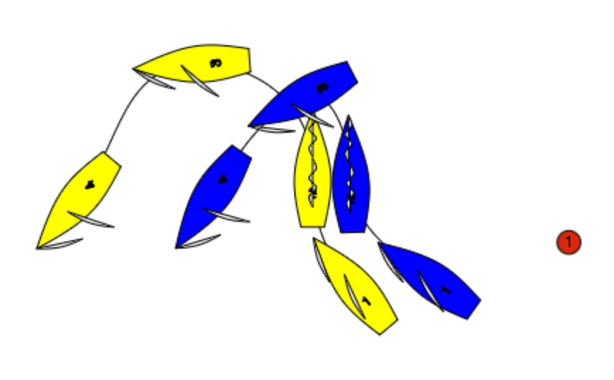
Rule 23.2 applies. The first question the umpires should ask is “ Is Blue sailing her proper course”? In this case Blue’s proper course would be to tack, and certainly not sail as at position 4. Blue is not sailing a proper course, and as she is preventing Yellow from gybing she is interfering with a boat taking a penalty..so Blue breaks rule 23.2.

Case 2
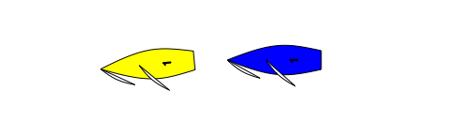

In the Prestart Yellow has been penalised, or has indicated that she will take a penalty. Blue sails close astern preventing Yellow from getting well clear in order to start her penalty turn. Yellow Protests. What should the call be?

Green and White Flag.

Rule 23.2 is only about interfering with a boat taking a penalty. Yellow is not taking a penalty as she has not sailed well clear and in addition as this is before the start there is no proper course.

See Team Race Rapid Response Call 2023.001

