Explanation 2 Interfering with a boat on a different leg.

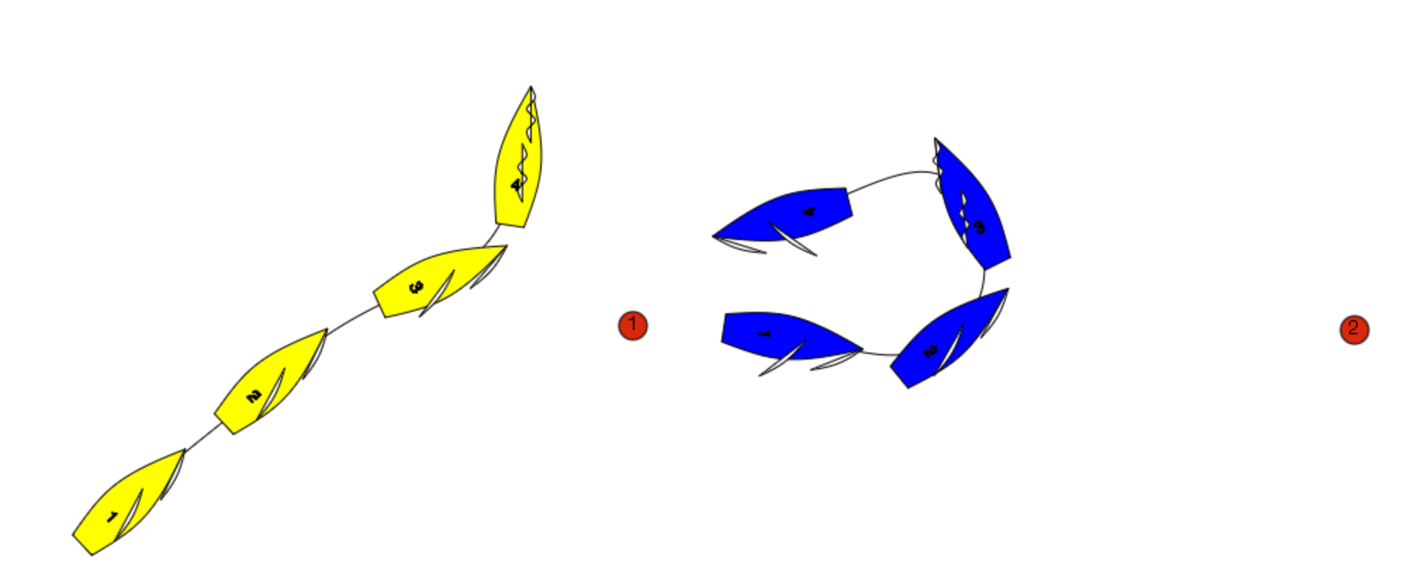

Blue has rounded mark 1 and is on the leg to mark 2. Yellow has yet to round Mark 1.
At position 2 Blue luffs and tacks back towards mark 1.
Immediately after position 3 Yellow has to change course to avoid Blue. There is a Protest. What should the umpires do?

Answer:

Blue is on another leg of the course to Yellow at position 3 and 4 because she could sail to either side of mark 1. Additionally Blue is not sailing a proper course. Because Yellow has to change course to avoid Blue, Blue has interfered with Yellow. Penalise Blue.
Rule 24.2 Except when sailing her proper course, a boat shall not interfere with a boat taking a penalty or sailing on another leg.

