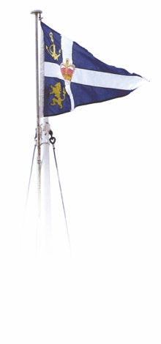

###### ROYAL NORTHERN & CLYDE YACHT CLUB

### ENTRY FORM

**BRITISH ISLES KEELBOAT TEAM RACING LEAGUE**

**Saturday 20th and Sunday 21st July 2019**

Team Name ……………………………………………………………………………………

Team Contact ……………………………………………………………………………………

Address ……………………………………………………………………………………

……………………………………………………………………………………

Post code …………………. Phone …..…………………………

Email ……………………………………………………………………………………

I agree to be bound by the Racing Rules of Sailing and all other rules that govern this event. In particular, I confirm that I have read the Notice of Race and accept its provisions and agree that my boat will conform to the requirements set out in the Notice of Race throughout the event.

Signed (On behalf of the team entered) …………………………………………………………………

NOTES All helms will be required to sign a copy of this declaration at registration.

An additional disclaimer may be required at registration from a parent or guardian of any competitor that is under 18 years of age. This is available in advance on request.

Top of Form

Please enclose a cheque for £ 320.00 

Bottom of Form

Or call RNCYC between 09.00 and 12.00 to make payment by Credit Card 

Or make Payment on line to RNCYC at the Royal Bank of Scotland 

Sort Code 83-23-03 Account number 00250061 (By order of: *team name* Ref: 2B*TR*)

The entry form and fee is to be returned to:

|  |  |
| --- | --- |
| The Office Manager | mail@rncyc.com |
| Royal Northern and Clyde Yacht Club |  |
| Rhu |  |
| Helensburgh |  |
| Scotland G84 8NG | 01436 820 322 |