Explanation 3 Interfering with a boat taking a Penalty

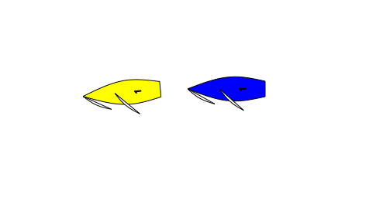

In the Prestart Yellow has been penalised, or has indicated that she will take a penalty. Blue sails close astern preventing Yellow from Getting Well Clear in order to start her penalty turn. Yellow Protests. What should the call be?

Green and White Flag.

Rule 24.2 is only about interfering with a boat taking a penalty. Yellow is not taking a penalty as she has not sailed well clear.

24.2 Except when sailing her proper course, a boat shall not interfere with a boat taking a penalty or sailing on another leg.

