Rules Explanation 8

Finish Line

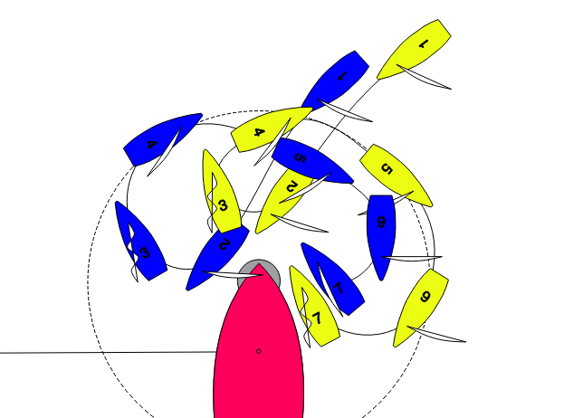

Blue and Yellow are approaching a downwind finish line.

At the zone Yellow is overlapped to leeward of Blue ( but neither boat actually realised this)

At position 2 Yellow makes contact with Blue's stern (sticks) and signals she will take a voluntary penalty (a single tack). Blue does not touch the CV.

Blue needs to keep Yellow is last to win the race so when Yellow tacks, Blue also tacks.

At no stage does either boat leave the zone.

At position 4 both boats have completed their tacks and Blue is astern of Yellow.

At position 5 the boats become overlapped as a result in part of Yellow bearing away.

Immediately the overlap is established Blue bears away hard and gybes.

Yellow also gybes ..the overlap is never broken.

At position 7 were is contact between Blue and Yellow, but none with the CV.

There is a protest.

At position 1 RRS 18.2 (b) applies and Blue shall give Yellow mark room

At position 2 there is contact between Yellow and Blue, Blue protests and Yellow decides to take a voluntary penalty.

At position 4 Yellow the boat entitled to mark room passes head to wind. RRS 18.2(d) applies and thus 18.2 (b) ceases to apply. But RRS 18.1 states that RRS18 applies. But as the boats are not overlapped neither must give the other mark room.

At position 5 an overlap is established at least in part because of Yellow bearing away. RRS 18.2(a) applies.

Yellow (despite being to windward of Blue) is the inside boat. (this is where I got it wrong)
Immediately the overlap is established Blue does everything she can to give Yellow mark room. (Note RRS 18.2 (f) does not apply as the conditions are not met.

At position 7 there is contact between Yellow and Blue.

Penalise Blue for breaking RRS 18.2(a)

