Explanation 5 Approaching and Leaving a marks

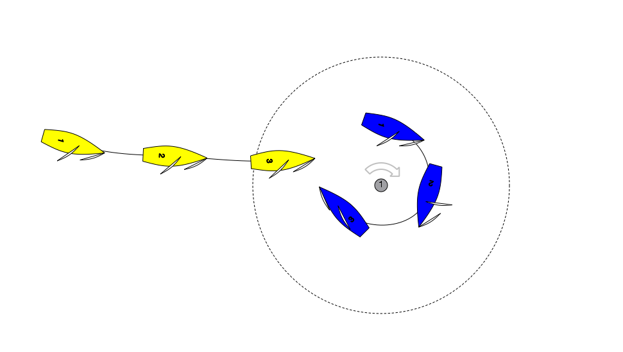

Question: Blue enters the zone of the Leeward mark clear ahead of Yellow. Blue rounds up to a proper course and immediately after position 3 has to bear away sharply to avoid a collision. Blue protests. What should the call be.

Answer: Green and White Flag. As drawn yellow is approaching the mark and Blue is leaving the mark. Therefore Rule 18 does not apply. Blue the right of way boat is restricted by Rule 16 and when changing course must give Yellow room to keep clear. By bearing away Blue has given Yellow Room to Keep Clear (see Call D3.)

Yellow in addition must make every effort to keep clear.

