Explanation 4 Windward Dial Down

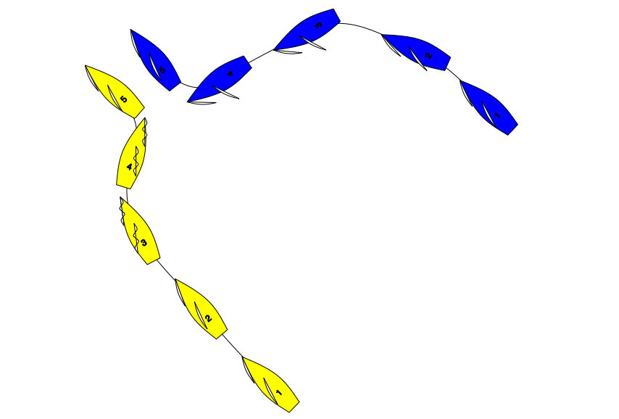

On a beat to windward. At position 3 Yellow starts to luff to tack. Blue bears away hard as shown and holds her course. At position 4 Blue makes a valid protest, and both boats change course to avoid a collision. What should the call be?

Answer: Penalise Yellow.

In position 1,2 and 3 Blue is windward keep clear boat.
At position 4 Blue becomes right of way boat as a result of Yellow’s actions.
Rule 15 and 16 do not apply as Blue has not changed course.

Yellow breaks rule 10.

Note: if after Yellow passes head to wind Blue changes course, then Blue is subject to rule 16. In which case the answer is Green and White Flag.

