Explanation 2 Interfering with a boat on a different leg.

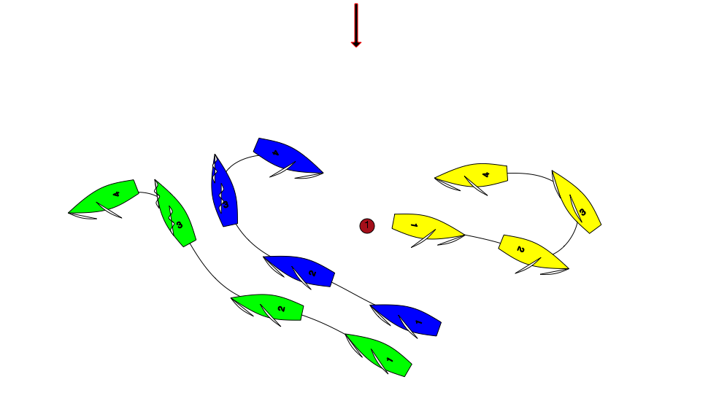

Yellow and Green are team mates.

Yellow has passed mark 1 and is on the leg to mark 2. Blue and Green have yet to round Mark 1.

At position 2 Yellow luffs and tacks back towards mark 1.

Immediately after position 4 Blue has to change course to avoid Yellow. There is a Protest. What should the umpires do?

Answer:

Blue is on another leg of the course to Yellow. Yellow is not sailing a proper course. Because Blue has to change course to avoid Yellow, Yellow has interfered with Blue. Penalise Yellow.
Rule 24.2 Except when sailing her proper course, a boat shall not interfere with a boat taking a penalty or sailing on another leg.

