Explanation 1 Finish Line

Blue enters the zone of the Committee Boat clear ahead of Yellow.
Blue sails high ( to luff an opponent), at position 3 Yellow establishes an overlap from astern.
What are the limitations ( if any) on Blue when she gybes onto port.

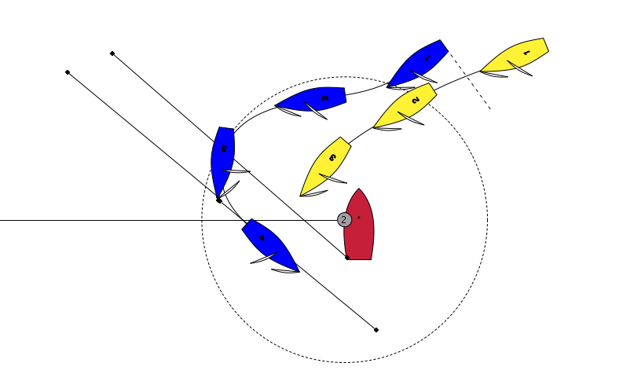

Answer: When Yellow becomes overlapped on Yellow, 18.2 (c) 2 applies.
“ if she becomes overlapped inside the boat entitled to mark-room, she shall also give that boat room to sail her proper course while they remain overlapped. “
Therefore Blue only has room to sail her proper course, which is to finish as quickly as possible.
The angled lines show gybe lines. By gybing at position 3 Blue has left space for Yellow to finish inside her.
Note: It is never a proper course for Blue to point above the port quarter of the committee boat.

